# Durable Furnitures

Interlude Home

## Twining Leaf Mini Pendant

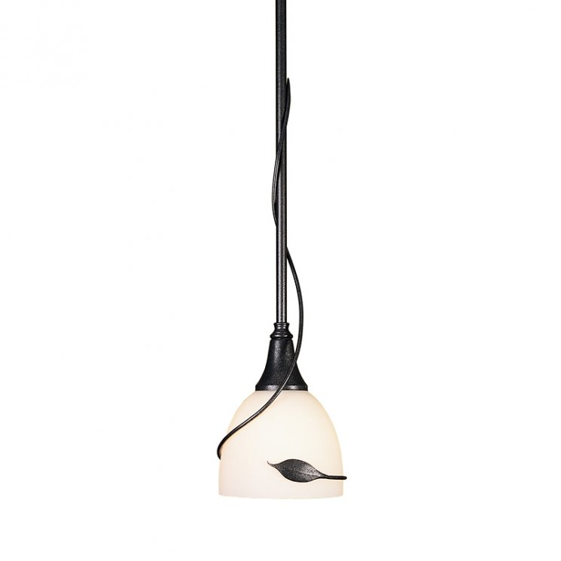

A flawless example of Sylvan design, our Twining Leaf Mini Pendant by Hubbardton Forge evokes a sense of natural harmony for the home. The hand-forged leaf form found at the center of this artful design has become a treasured silhouette for Hubbardton Forge artisans and recognizable for its one-of-a-kind tailoring. All who gaze upon this timeless pendant become engrossed in the meandering tendril of iron encircling a delicate glass shade.